Module 22 – Financial Assets
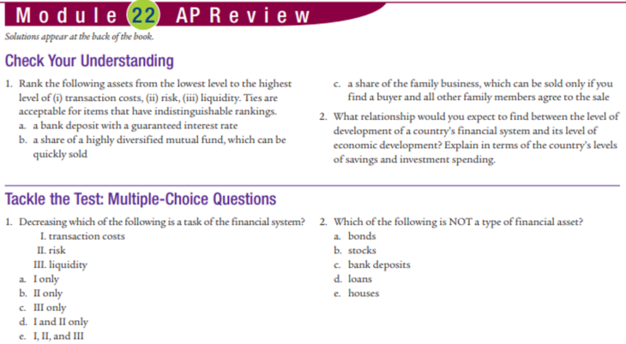
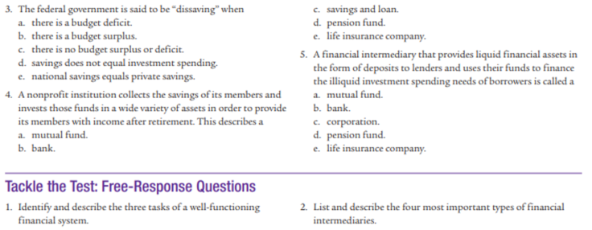
Answers:
1. Transaction costs: a,b,c Risk: c,b,a Liquidity: c,b,a 2. More developed countries will have a more developed financial system
MC: 1d 2e 3a 4d 5b
Free Response:
1. Smooth depositing, lending, transactions 2. Mutual Fund –takes customers money and grows it for them, Bank – takes savings and lends to borrowers, Retiremend fund – similar to a mutual fund but for retirmement money, Insurance company – takes payments from people for protection against risk

